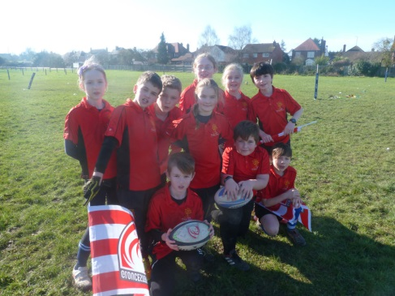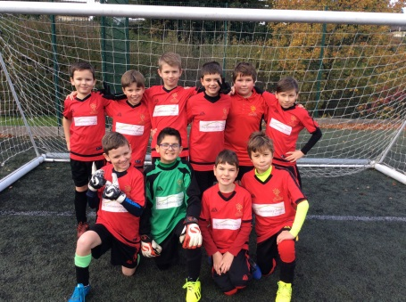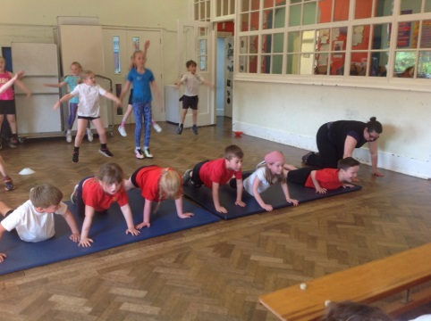

**PE INTENT**

Early Years Foundation Stage Curriculum

Aims

All children following the Early Years Foundation Stage curriculum should:

* Show good control and co-ordination in large and small movements.
* move confidently in a range of ways, successfully negotiating space
* handle equipment effectively
* know the importance for good health of physical exercise and a healthy diet

National Curriculum

Key Stages 1 and 2

Purpose of study

A high-quality physical education curriculum inspires all pupils to succeed and excel in competitive sport and other physically-demanding activities. It should provide opportunities for pupils to become physically confident in a way which supports their health and fitness. Opportunities to compete in sport and other activities build character and help to embed values such as fairness and respect.

Aims

The national curriculum for physical education aims to ensure that all pupils:

* develop competence to excel in a broad range of physical activities
* are physically active for sustained periods of time
* engage in competitive sports and activities
* lead healthy, active lives.

**What are children say about PE at Uley School**

I really enjoy our Uley sports day! I love competing for our teams!

Really

I r

I enjoy playing lots of team games outside.

**WHAT PE LOOKS LIKE AT ULEY SCHOOL**

At Uley Primary School by participating in P.E. lessons the children will have the opportunity to achieve the following objectives:

* To become skilful and intelligent performers, and to develop a range of skills with increasing competence and confidence, in varying physical activities and contexts.
* To develop their ideas in a creative way and learn how to select and apply skills, tactics and compositional ideas.
* To take the initiative, lead activities and focus on improving their performance.
* To discover the notion of fair play, honest competition and being a good sport, including how to co-operate with each other and work successfully in pairs, groups or teams.
* To develop self-confidence through the understanding of one’s own capabilities and limitations.
* To be motivated, so that they retain a lifelong interest in all aspects of P.E. and recognise the importance of living and maintaining a healthy life.