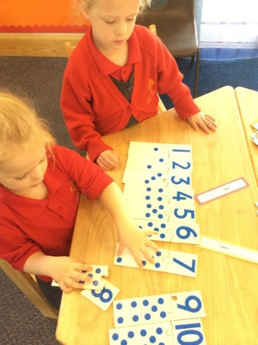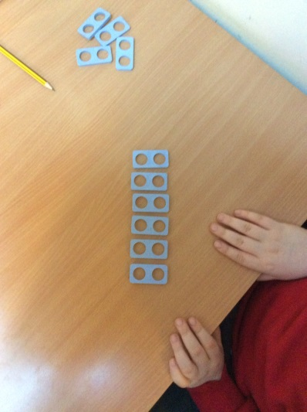

Early Years Foundation Stage Curriculum

**Aims**

Children in reception aim through the foundation stage curriculum to:

* Count reliably from 0-20, place numbers in order, know one more and one less, using quantities and objects to add and subtract two single-digit numbers and solve problems including sharing, doubling and halving.
* Children use everyday language about size, weight, capacity, position, distance, time and money. They recognise, describe and create patterns and explore the characteristics of shapes.

National Curriculum

Key Stages 1 and 2

**Aims**

The national curriculum for mathematics aims to ensure that all pupils:

* Become fluent in the fundamentals of mathematics, including through varied and frequent practice with increasingly complex problems over time, so that pupils develop conceptual understanding and the ability to recall and apply knowledge rapidly and accurately.
* Reason mathematically by following a line of enquiry, conjecturing relationships and generalisations and developing an argument, justification or proof using mathematical language
* Can solve problems by applying their mathematics to a variety of routine and non-routine problems with increasing sophistication, including breaking down problems into a series of simpler steps and persevering in seeking solutions.

**MATHS INTENT**

**WHAT MATHS LOOKS LIKE AT ULEY SCHOOL**

At Uley Primary School we believe Mathematics is a tool for life. To function in society, we all need to be able to communicate mathematically. We must ensure that the children in our care leave our school with high standards of numeracy as well as literacy. At Uley we teach mathematics so that our pupils develop their understanding and enjoyment of the subject, and this includes linking the subject where possible to concepts in our everyday lives and other subject areas.

In our teaching of mathematics at Uley, we hope to:

* inspire an enjoyment and love of maths
* ensure pupils are numerate, have good mental arithmetic skills and understand that maths is everywhere
* enable pupils to have opportunities for mathematical thinking and discussion, using mathematical vocabulary as well as reasoning and problem solving opportunities
* provide occasions for pupils to demonstrate and use their mathematics across other subject areas
* instil confidence at using mathematics and challenge pupils to ‘be the best they can be.’

**WHAT THE CHILDREN SAY ABOUT MATHS AT ULEY SCHOOL**

‘I like having my buddy or friend to help me in Maths’

‘I like getting stuck in Maths because it helps me to think about my mistakes and challenge myself’

‘I like playing maths games on the Ipads, especially ‘Hit The Button’’

‘I like using Numicon to make 100. It helps me with the different numbers and colours’