Please support your child to choose a minimum of four activities to complete at home over this term. Due to exceptional circumstances, all homework will need to be received digitally and can be sent to the Class 4 email account (class4@uley.gloucs.sch.uk), which will be made available during the week beginning 23rd November. Any homework completed and sent to the class 4 email account will receive 5 team points. Once all homework has been received, the children’s work will be celebrated and shared amongst the class and individual team points will be collected and awarded.
Write a diary entry from the perspective of an Anglo-saxon or Viking travelling to Britain. Where in Britain did you land? Did you face any battles when you arrived? If so, against who? | Write your own riddle or Kennings poem. Extra challenge: can you make your poem rhyme?  Can you video record yourself performing your poem for extra points? |  | Have a go at creating your own Viking or Anglo-Saxon shield/weapon. Can you show the process from design to making the weapon/shield? |  |  | On a map of Europe and the UK, show which countries the Anglo-saxons and Vikings travelled from and where they landed in Britain.  Can you find out how far they would have travelled from their original home countries to arriving in Britain? |  |  | Can you create your own drawing of a rainbow?  Can also you explain what you hopes and dreams are for this year?
This term’s topic is Here we are! Have a go at completing a range of homework activities to explore this topic even more. 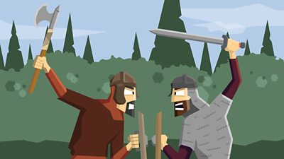 |  |  |  | Can you create a piece of music to help portray a battle scene? Think about how to use tempo and dynamics to portray the different emotions the fighters may have felt during the battle. |  |  |  | Have a go at creating your own representation of the creation story. You can create your representation on the computer, or by making a 2d/3d piece of artwork.
 |  |  |  | Can you create your own supermover exercise routine to music and video record yourself performing the routine for the class to have a go at?
Create your own fact file sheet/presentation about the Anglo-saxons and Vikings. Try to include some information from what you have learnt in school. |  | Design and create a representation of an Anglo-saxon village, you can create a village on a computer programme. |  |  | Have a go at playing some different Anglo-Saxon board games including fox and goose/Nine Men’s Morris. Using inspiration from these games can you design and create your own board game? Can you write a set of instructions for how to play the game? |  | Write your own short story about a battle between the Vikings and the Anglo-Saxons. Explain what happened during the battle. Who won?  Points for the tasks have been calculated in regards to depth and effort needed to complete the task successfully. We recommend choosing a range of activities across the subject range. If you require any equipment/resources to help complete the tasks please do not hesitate to ask!
We recommend choosing a range of activities across the subject range. If you require any equipment/resources to help complete the tasks please do not hesitate to ask! These tasks are to be completed in addition to regular home reading and spelling homework.
The homework tasks can also be supplemented with practising Rainbow Maths, completing Mathletics tasks and practising their individual times tables. All Rainbow Maths sheets can now be found on the school website, please just let us know if you would like a hardcopy/any answer sheets.

