Dear Class 4 Parents, Monday 23rd September 2019

Welcome back to a new school year at Uley! I hope you had a wonderful summer holiday and a well-deserved break! I am pleased to see Class 4 have settled in well and are looking forward to an exciting and busy term.

This term, the whole school topic is ‘Way back when…’. In Class 4 we will be travelling back to Ancient Greece and will be learning and understanding how Greek discoveries, theories and traditions had such an important impact on our lives today!

Alongside the exciting topic this term, the children will also be participating in lots of fun activities across the curriculum. Below is an overview of the areas we will be focusing on this term:
Maths  This terms Maths lessons will focus on learning and revising their understanding of place value and the four calculations - addition, subtraction, multiplication and division.  This terms times table focus:  Year 5: revising the 7 times tables.  Year 6: revising the 9 times table.  Please encourage the children to keep practising their times tables at home. Resources to support times table practice can be found on the school’s Maths page. | English  Fiction:  This term the children will be reading a range of Greek myths and will be writing their own Greek myth inspired by versions they have read.  The children will be learning all about the important battles and wars the Greeks fought in and will be using this for inspiration when writing from the perspective of a Greek soldier.  Non-fiction:  Linked to their Science unit (Earth, Sun and the Planets) the class will be writing their own non-chronological reports about a planet of their choice.  They will also be writing biographies about famous Greek philosophers, astronomers and architects that have made a significant impact on our history and the way we view the world today.  Poetry unit: This term the class will be exploring free verse poetry and narrative poetry.
Computing/ICT  E-safety lessons  Until Christmas, the focus for ICT lessons will be on E-safety. Class 4 will be covering the E-safety topics of: Strong passwords, privacy rules, the digital citizen pledge and cyber bullying (linked to Anti-bullying week) | Music  This term’s music is linked to Class 4’s Science unit and is about exploring a ‘Journey into Space.’ During the unit the children will focus on the musical terminology of clusters, pitch and tempo, and will be using this when creating and performing a piece of music to the class. | Physical Education.  During the Autumn term the children will be participating in swimming lessons on a Friday afternoon.  Alongside the swimming lessons, Class 4 will also participate in 6 weeks of gymnastics followed by Netball sessions outside after October half term.  Please can P.E. kits stay in school from Monday to Friday in case of any timetable changes.
Live, Learn and Flourish Week
During the Live, Learn and Flourish week at the start of September the children discussed and explored the British Value of ‘Mutual respect.’ They also participated in PSHCE lessons linked to resilience, understanding what it means to show resilience and how we can be more resilient within school.
Art and Design  This term the children will be creating different 3d sculptures and models linked to their Ancient Greek topic.  During Class 4’s WOW day, they created their own Greek vase out of clay and explored the Ancient Greek Alphabet, writing their own secret code onto their scrolls. I look forward to displaying the Greek vases once they have been finished! | Science (Physics)  This term’s Science topic is Earth and Space.  During this Science unit the children will be learning all about the planets; describing and exploring the movement of the planets around the sun and how night and day occurs.  The class will also plan, predict and conduct a range of scientific investigations linked to shadows and will understand how to record and present their findings using scientific language. | R.E.  During R.E. lessons class 4 will be exploring the topic of Creation and Science and the question ‘conflicting or complementary?’  Worship  This term’s whole school value is Truthfulness. The children will be learning the importance of this value, including exploring how the value is shown within the gospel stories.
Exciting events happening in Class 4 (Dates to remember!)
On Wednesday 23rd October, the whole school will enjoy a range of life education sessions delivered by the Coram Education team. The sessions are an excellent opportunity for the children to discuss a range of topics relating to friendship and their personal and social needs. Class 4’s session will focus on …..

Class 4’s Live, Learn and Flourish worship will be on Wednesday 11th December at 9.10am. The worship will be an opportunity for Class 4 to showcase their work and learning from across the term and we look forward to welcoming parents and family members on the day.

This term, Class 4 will be attending swimming sessions at The Pulse in Dursley. Each swimming session will include an element of water safety where the children will learn about floatation, rotation and treading water. All sessions will be related to everyday situations which they may face when playing by or within water. On their final swimming session, the children will be required to bring a pair of shorts and tops to wear during the lesson. More information about the final session will be sent out nearer the time.

On a Friday, children in Class 4 will be participating in ‘My Special Thing’. This is a Year 5 and 6 privilege, and a fantastic opportunity for each member of the class to present and talk about something that interests them. Every child in the class has been given a date for their presentations (letters were sent out at the start of the term) and I am very much looking forward to seeing the variety of interests Class 4 have. If you have any questions regarding your child’s ‘My Special Thing’ please do not hesitate to pop in and see me.

Homework
Homework topic webs
In Class 4, the children are encouraged to complete both the homework topic web as well as their weekly spelling homework each term. The homework topic web is linked to all areas of the curriculum and each piece of homework encourages a skill relating to ‘research’, ‘make’, ‘apply’ or ‘practice’. Class 4 will also play an active role in discussing and choosing homework activities they would like to complete relating to our topics. We do ask that children try and complete a range of homework pieces (including at least one 10 point task) across a range of subject areas. The deadline for all homework pieces to be brought in is _____________, ready to share on _____________. However, if any homework is finished prior to the share day, they are welcome to bring it in earlier to share with the class.

Weekly spelling homework
As part of their spelling lessons in school, the children will receive weekly spelling homework. This will involve exploring a spelling pattern by researching words linked to the pattern and applying the words correctly within sentences. There will be an opportunity for the children to complete an ‘application task’ (if they would like to challenge their learning even more) which will involve applying the words to a longer piece of writing such as a diary entry or newspaper report. Children are required to hand in their homework on Monday morning and any tasks completed will receive team points. On Monday mornings, we will have a spelling test linked to the spelling pattern they have been researching. Overall, the weekly spelling homework will provide the children with more independence when learning a spelling pattern and a greater understanding when exploring the meaning of words.
Alongside the homework set in school, we ask children to continue to read at home regularly, use Mathletics to encourage Maths practice and to keep practicing their times tables. If you require any more Rainbow Maths sheets to keep practicing at home, they are now available on the school website or feel free to pop in and ask for some.

I look forward to another busy term ahead and sharing Class 4’s achievements with you!
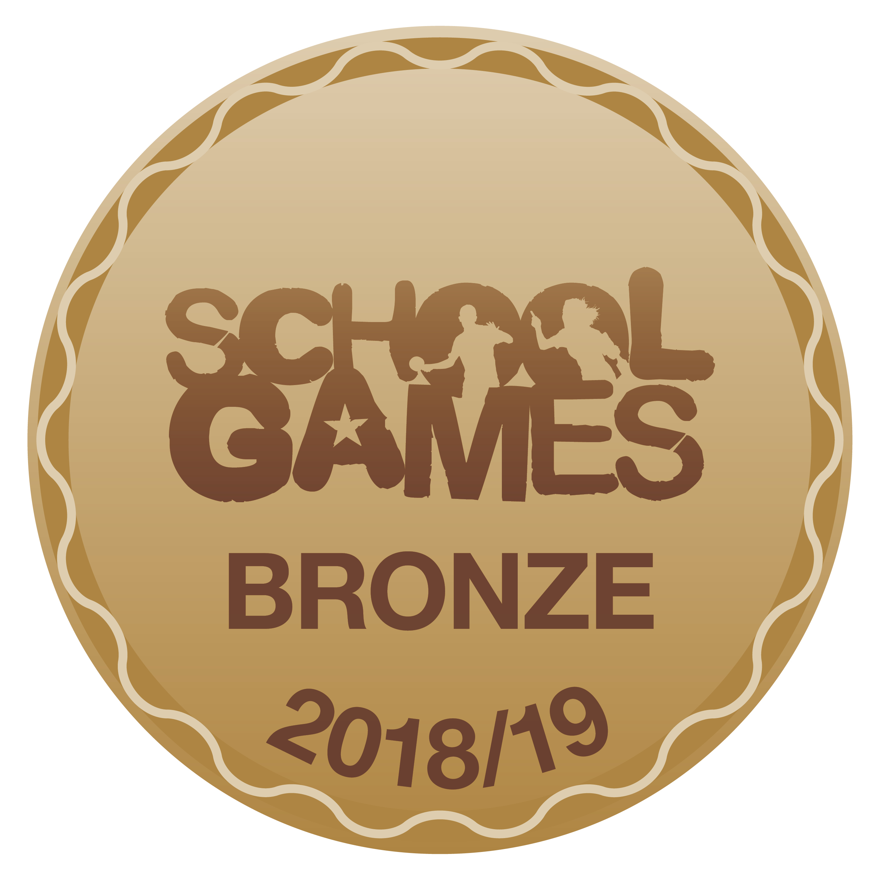
Kind regards
Miss Walker

