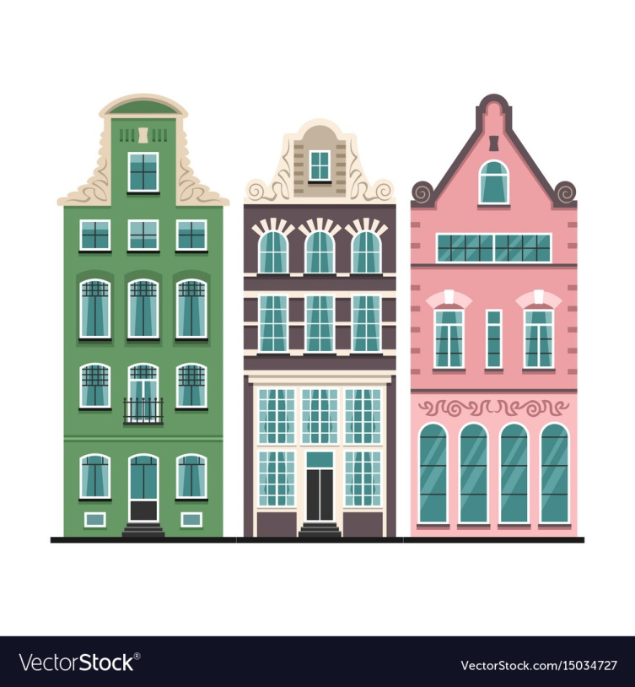

**KS2 Maths Competition Autumn term 1 2018**

**The Adams, the Browns and the Clarks live in three houses next door to each other with the Browns in the middle and the Adams at the house with the smallest number.**

**The house numbers differ by 2 and all three add up to 339.**

**What is the Clarks’ number?**

Please write your answer below and return the slip to Miss Walker in Class 3 by Friday 12th October.

Winners will be revealed before the week beginning 15th October.

**Autumn term Maths Competition KS2**

Name: Class:

The Clark’s house number is ________.